Assignment 3:

Implementation of temporal Table using stored procedure and its live query statistics

1. After creating a sample database for this, we need to create a Stored procedure which consists of creating table scripts with system versioning set to ON along with history table name. As shown below.

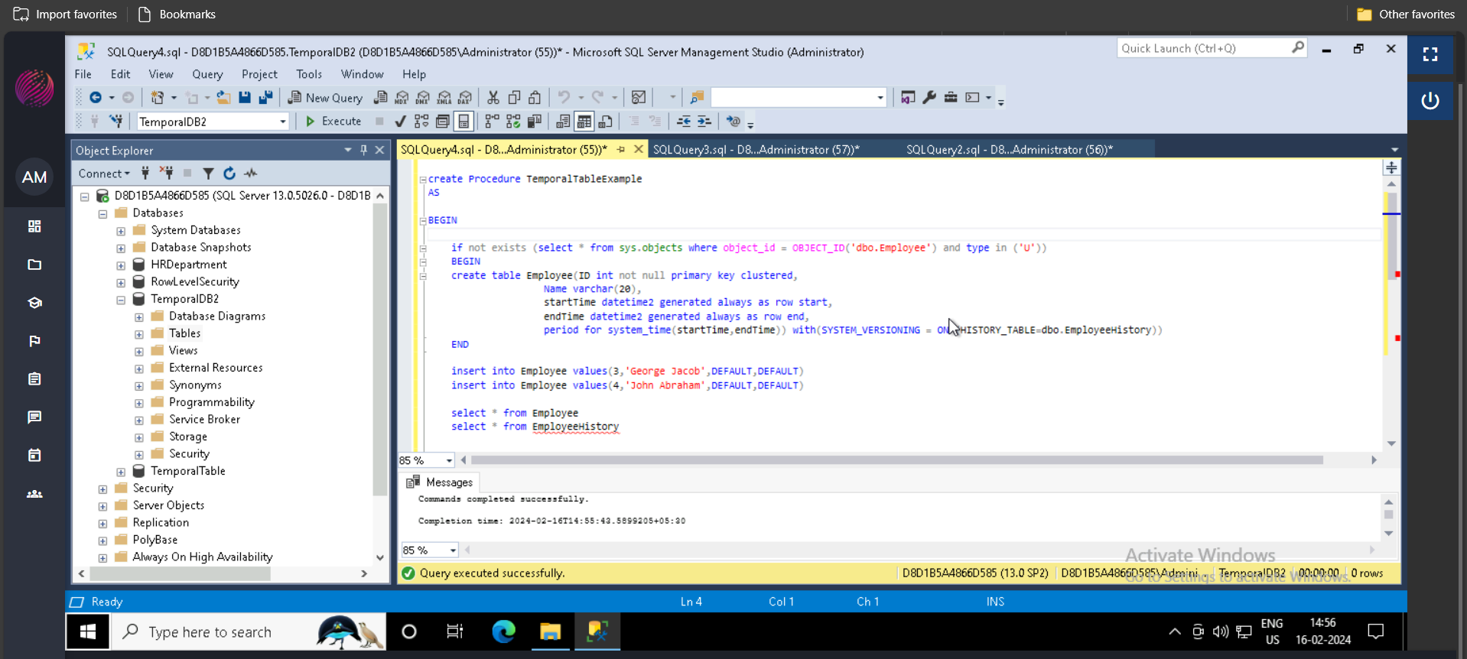

The SP also consists of insert commands to insert some data in it, also there are some DML commands (like update, delete) to perform some modification in data, this helps to implement the temporal table. As shown below

1. Now, we can perform a update query to the table and modify some data, as shown below.

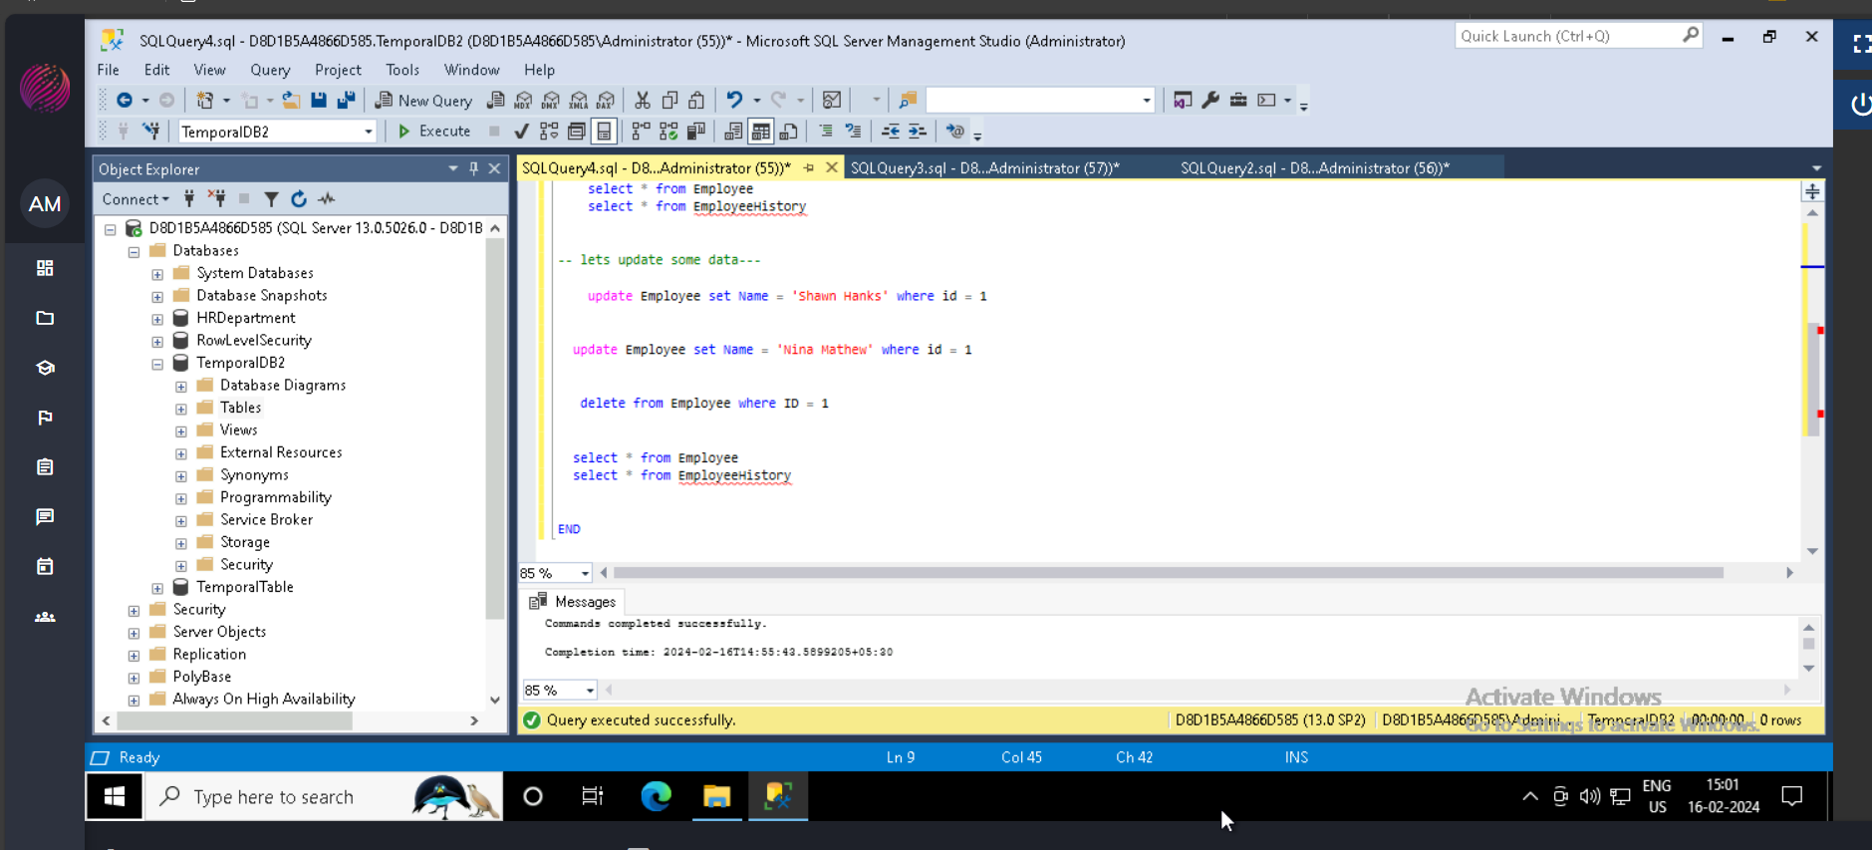

Post that, we executed the create procedure script as shown above, the SP will be created.

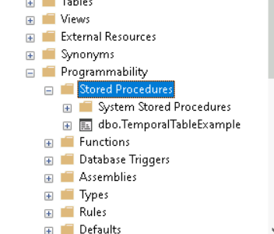

1. Upon executing the SP, it will create the table (i.e. temporal table) and it will insert some data in it also it will perform some DML commands as shown below.

Here, in result 1st table is current/original table with data inserted, since insert command is not part of data modification, the history table won’t capture it, that's why its shown empty in 2nd table.

But after some DML execution like update and delete command u can see the old data got captured in History table (Last table in result) with timestamp

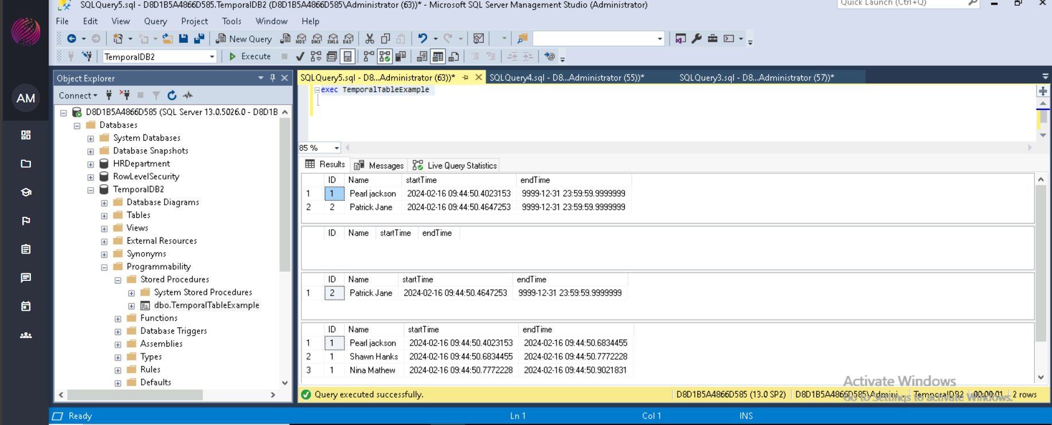

If we again perform update/delete or any DML command, the Modified data will again save into history table along with the timestamp, as shown in above snip.

Live Query Statistics for above scenario

This gives what happening in the background, while Stored Procedure is executed.

